subl . //打开sublime

browser-sync start --server --directory --files"**/*" //go to browser

Ctrl+Shift+I //chrome developer toor

Ctrl+K+B //sublime只显示右边

Ctrl+/ //批量注释

## W4L42P2

not defined!=undefined undefined只是没有赋值 not是没有定义变量

underfined means variable memory has been allocated but no value has ever been explicity set yet

not defined a variable has never been defined

## W4L40-41

### global&function

function-lexical

### Scope Chain

Everything is executed in an Execution Context

Each Execution Context has:

●Its own Variable Environment

●Specialn 'this' object

●Reference to its Outer Environment

Where function is physical defined determines the scope of function, not where it is executed.

-4

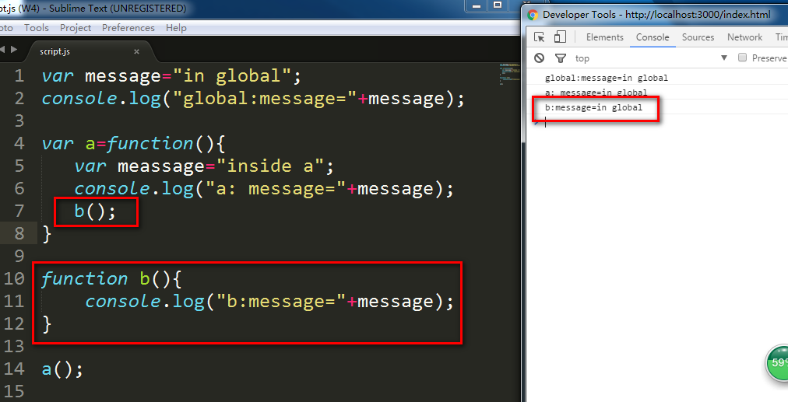

## W4L42P1

7 built-in types:6 primitive and 1 Object type

Object is a collection of name/value pairs

Primitive:Single value: some data in a name value pair,Immutable

Boolean

Undefined: no values has ever been set

Null: lack of value,can only have one value:null

Number: no integer subset of doubles

String

Symbol

## W4L43

Type coecion

The language converts something for you from one tye to another type automatically on the fly

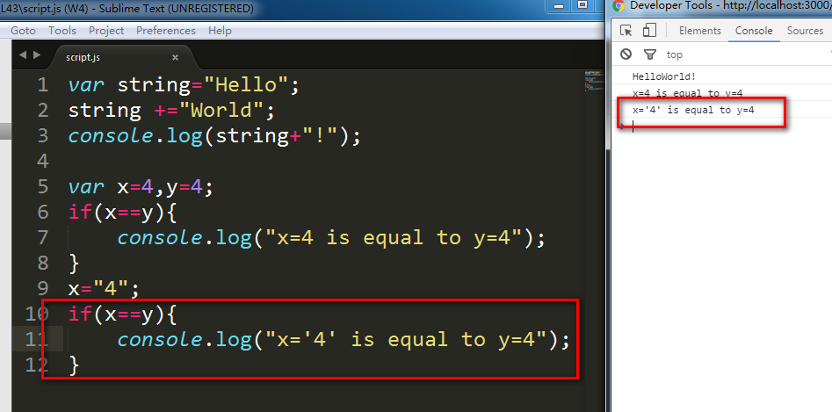

Strict equality

=== first compare type, then compare value

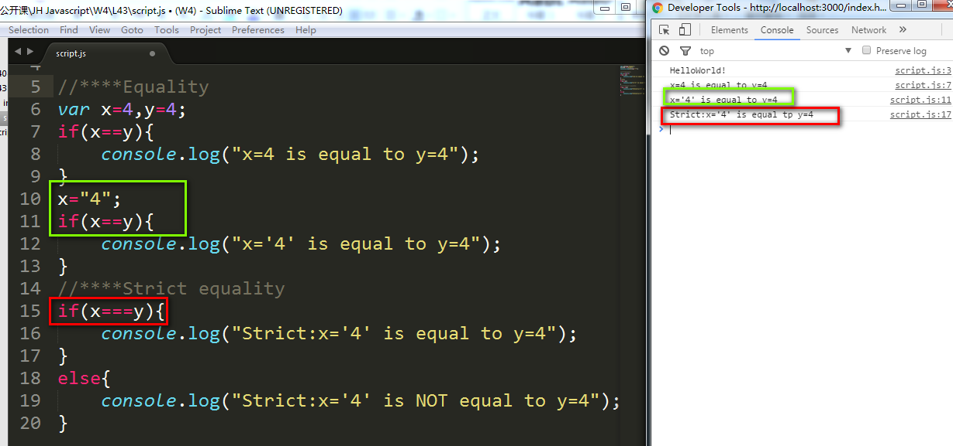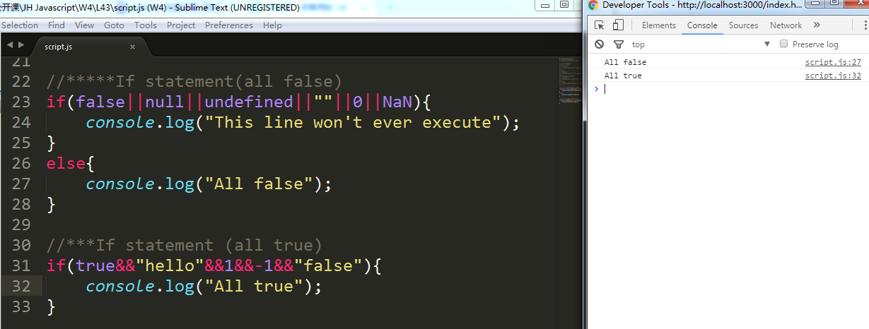

### Curly Brace

JavaScript engine doesn’t see anything after return, and palaces for you, a semi-colon right after it----return;

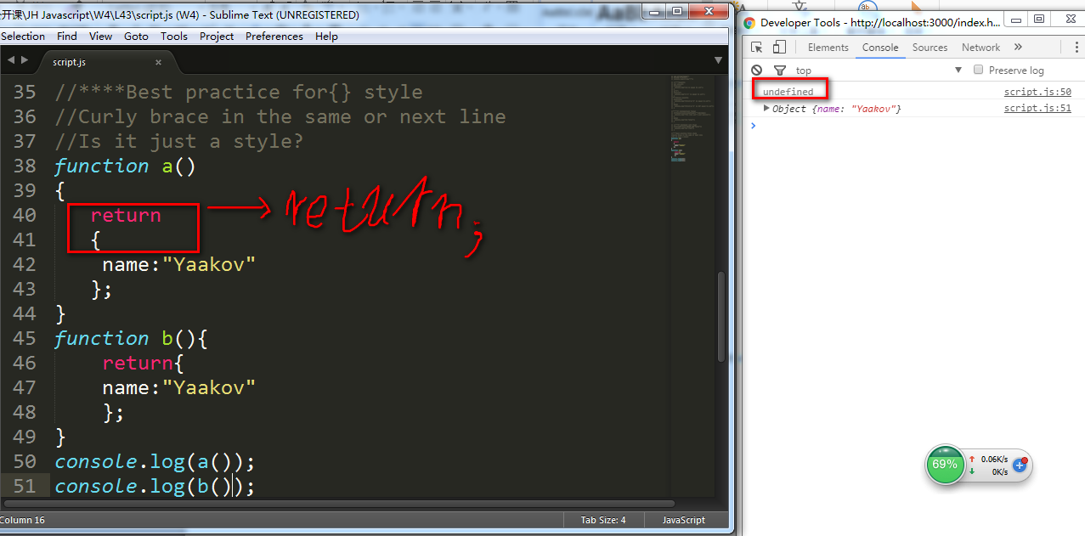

## W4L44

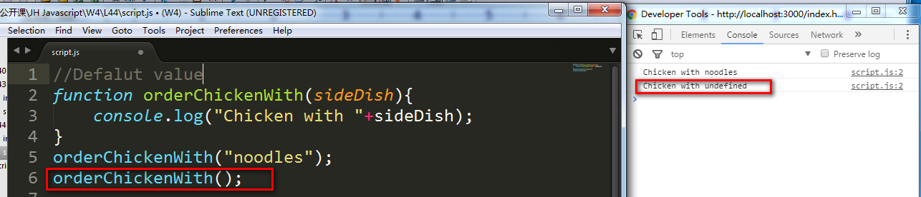

## W4L45-49

Javascript create property if the former one is defined

Company.ceo is something that hasn’t been defined

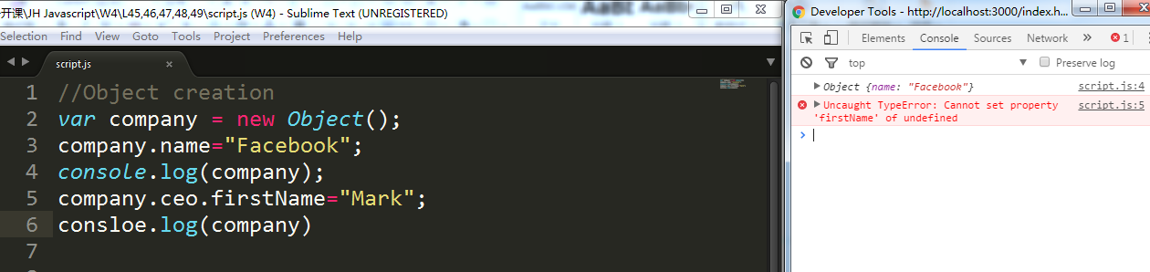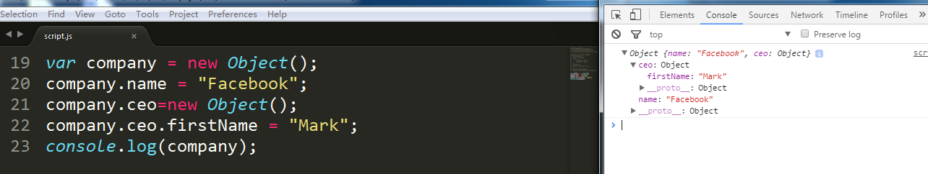

Dot notation will only work with whatever is a valid JavaScript identifier, or valid JavaScript, either function name, or valid JavaScript variable name

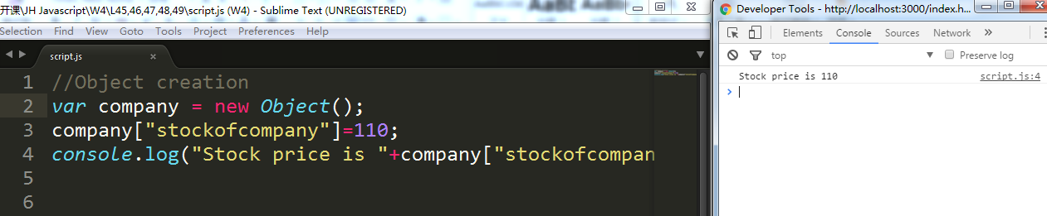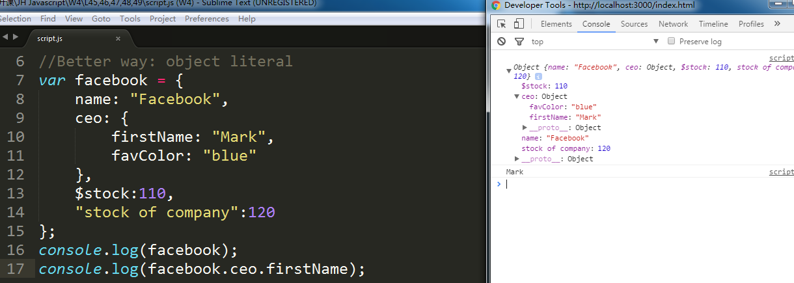

Every object has this inherent method or inherent function to it that’s called to strings

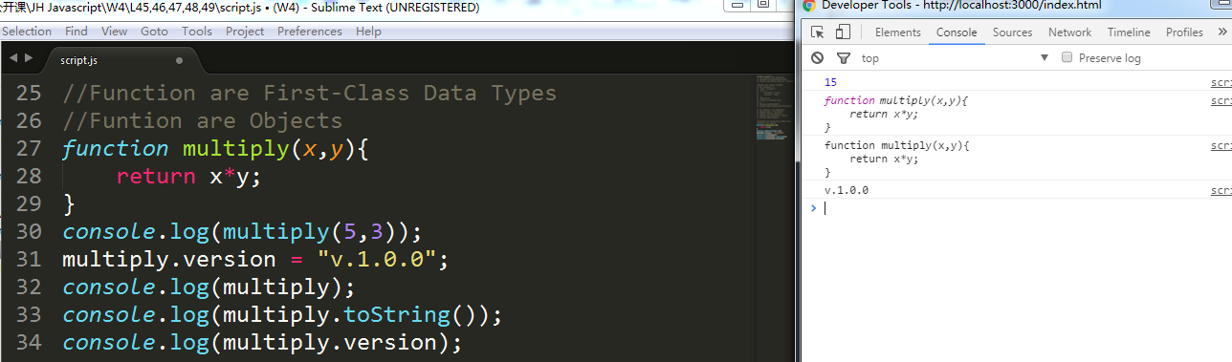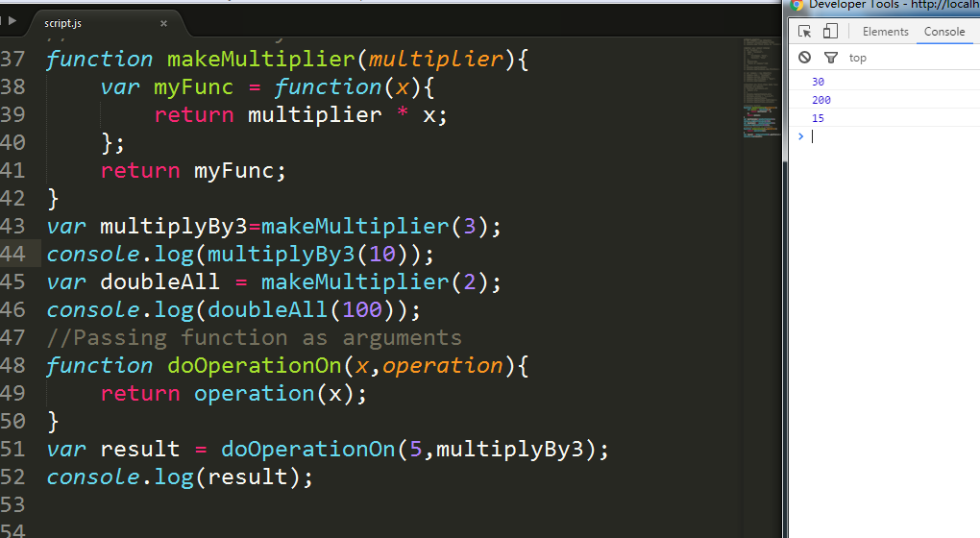

Passing Variables by Values vs by Reference

Given b=a, by value means change b not affect a, by reference change b affect a

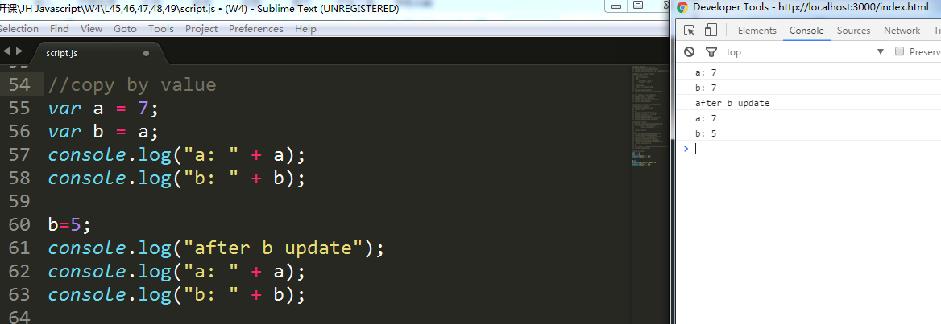

Primitives are passed by value,objects are passed by reference

Reference literal

Var a = {x: 7};

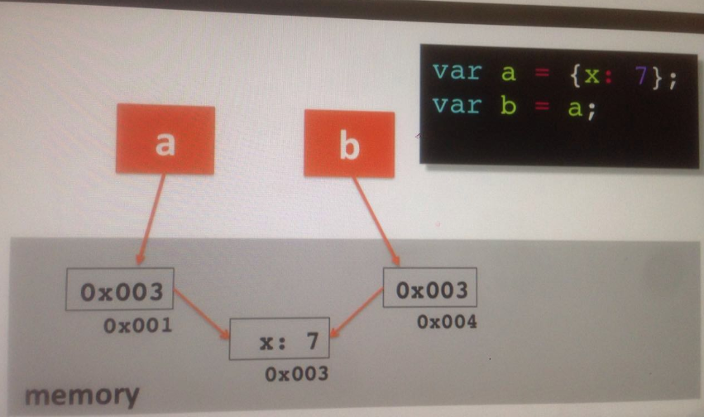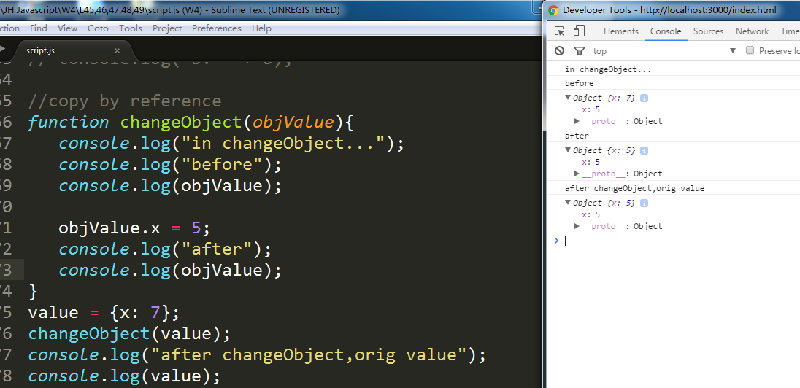

Global window object

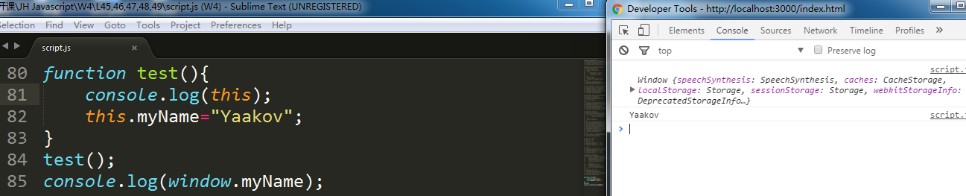

Function construction

We cannot return anything from the function constructor,it has to remain without a return value

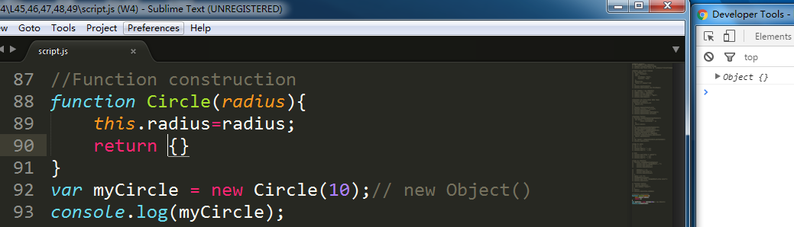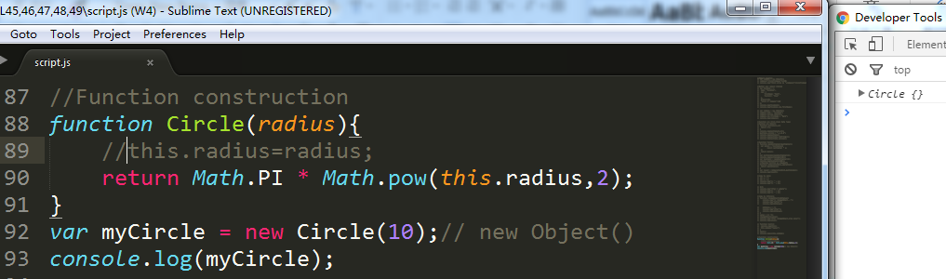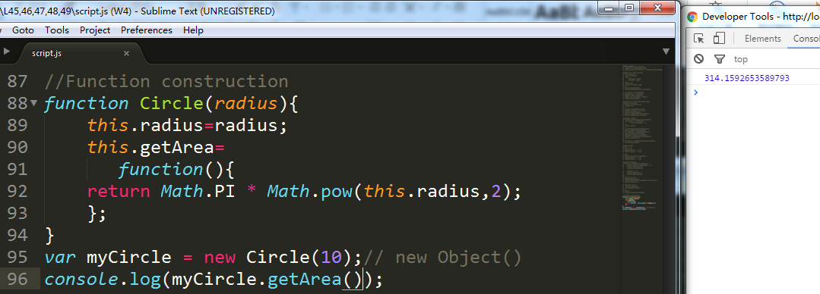

How this keyword behaves itself when it’s part of a function constructor.It’s referring to the function itself, or the object itself when the function is invoked together with the new keyword

myCircle.prototype.getArea don’t waste processing

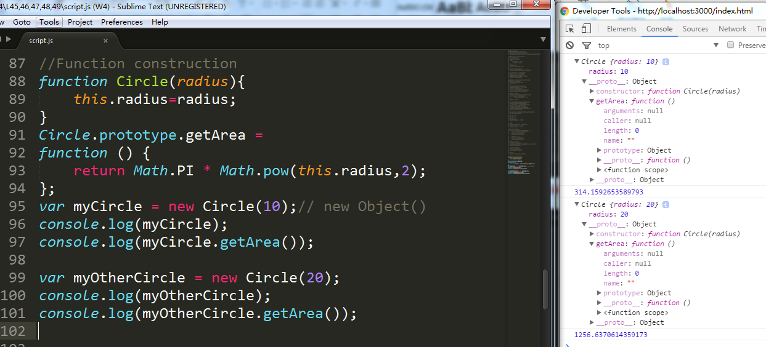

Object literals and how the this keyword behaves itself inside of one function:

When you have an inner function with another function, this keyword starts pointing to the global object. This is a bug of javascript, it will fix in next vision.

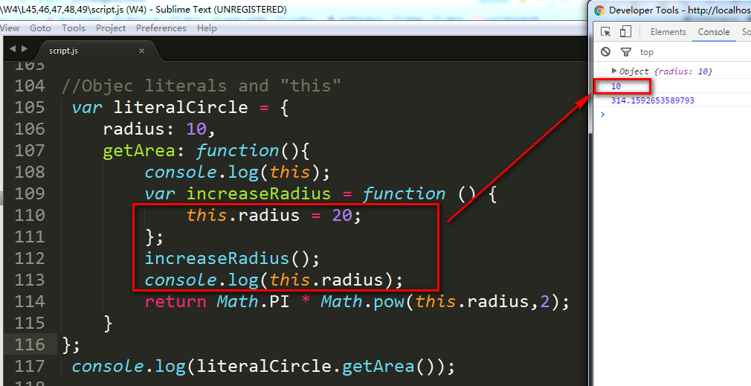

## W4L50-52

Array

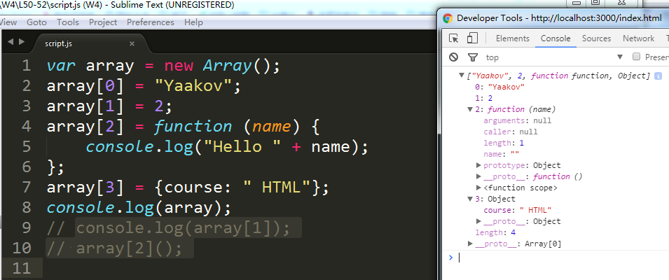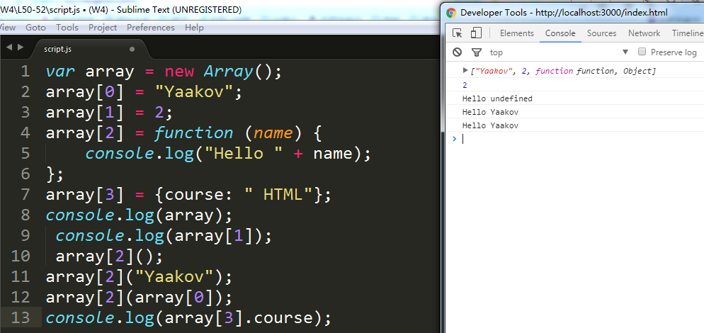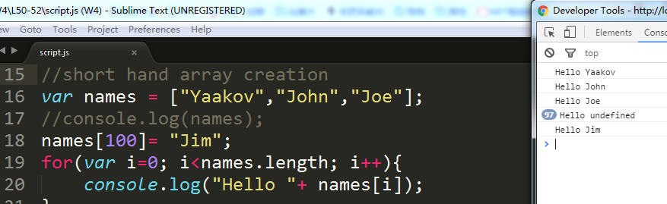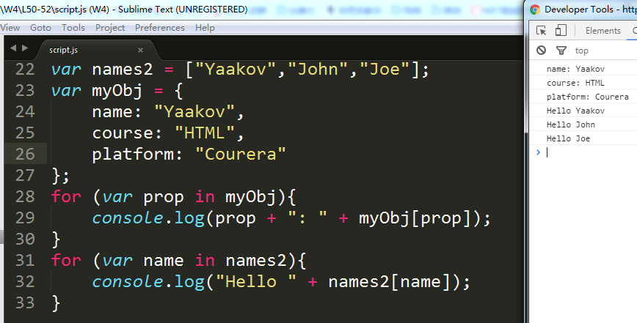

The array no different than a number zero and so on. Greeting beci-omes a property of the array and this for loop loops over the property names of the object. Array is an object

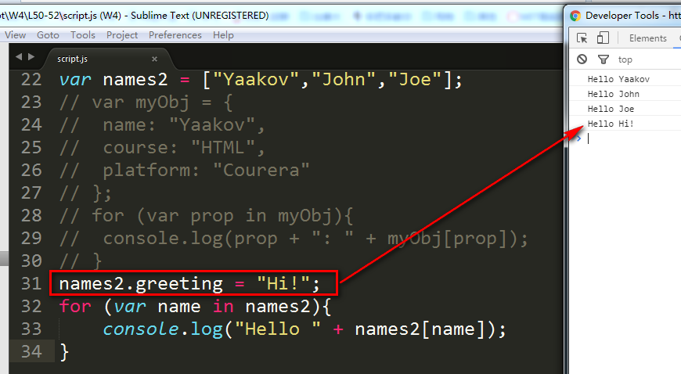

### Closure

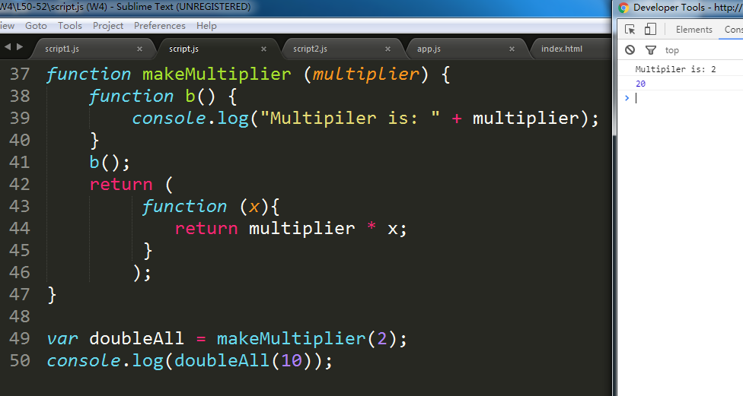

### Name Spaces

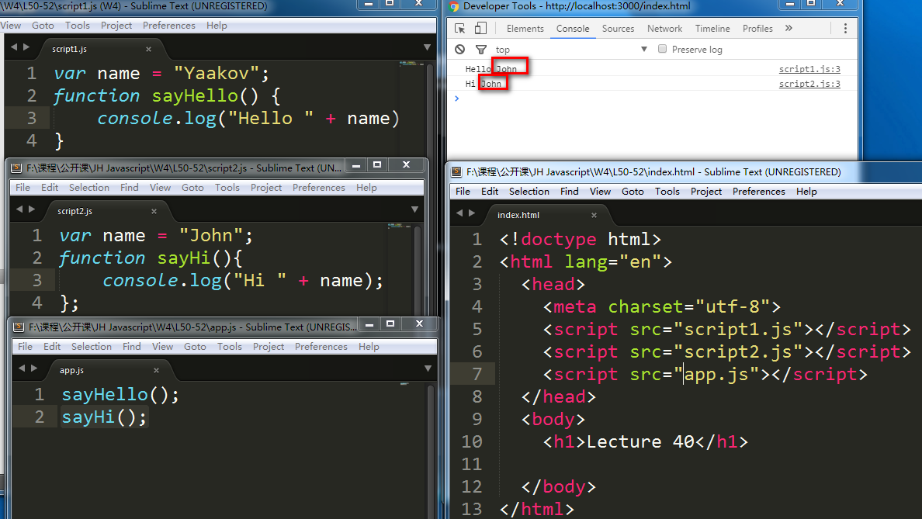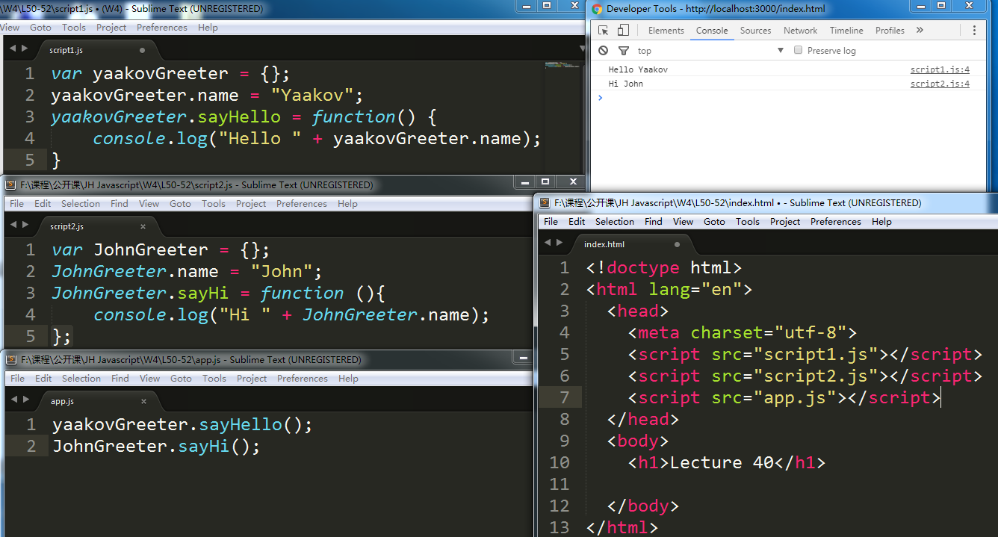

### Immediately Invoked Function Expression(IIFE)

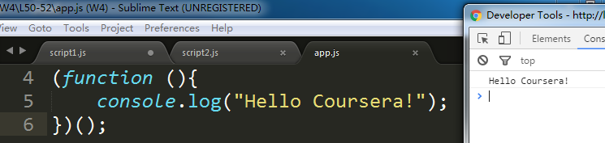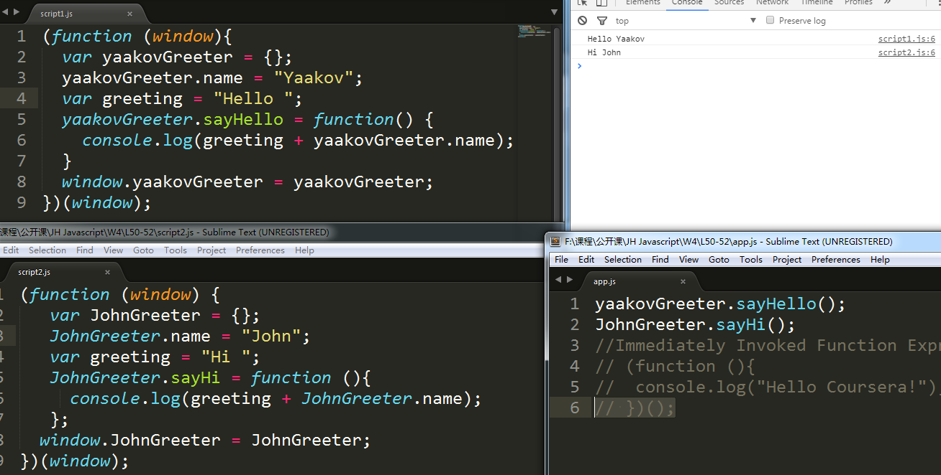

## W5L53-55

### DOM manipulation

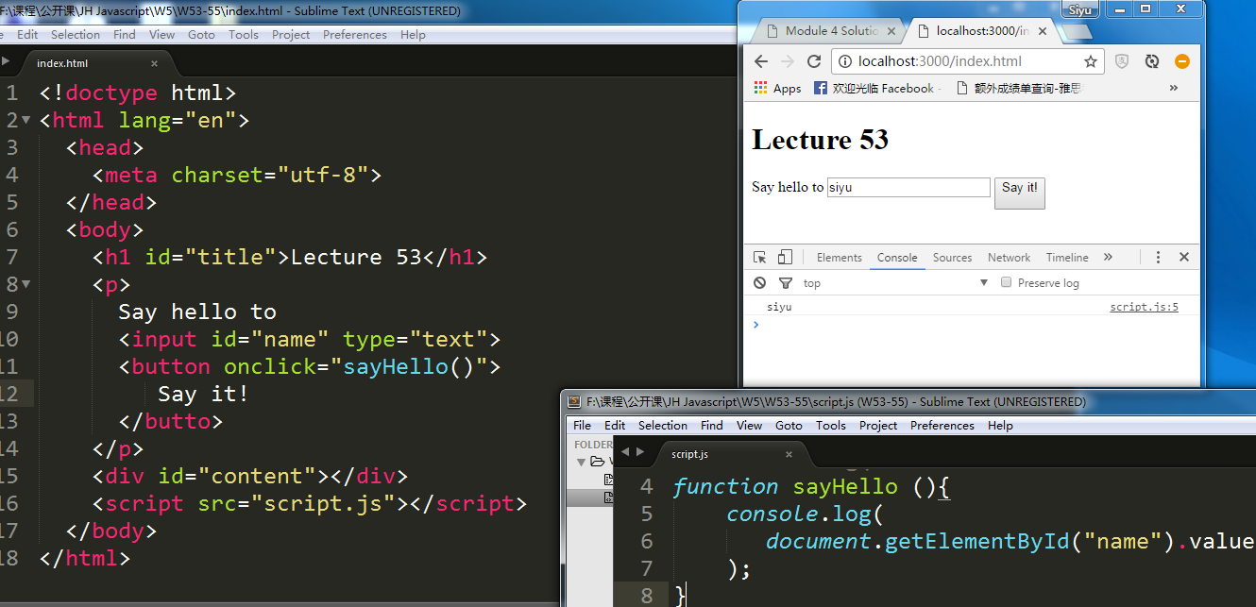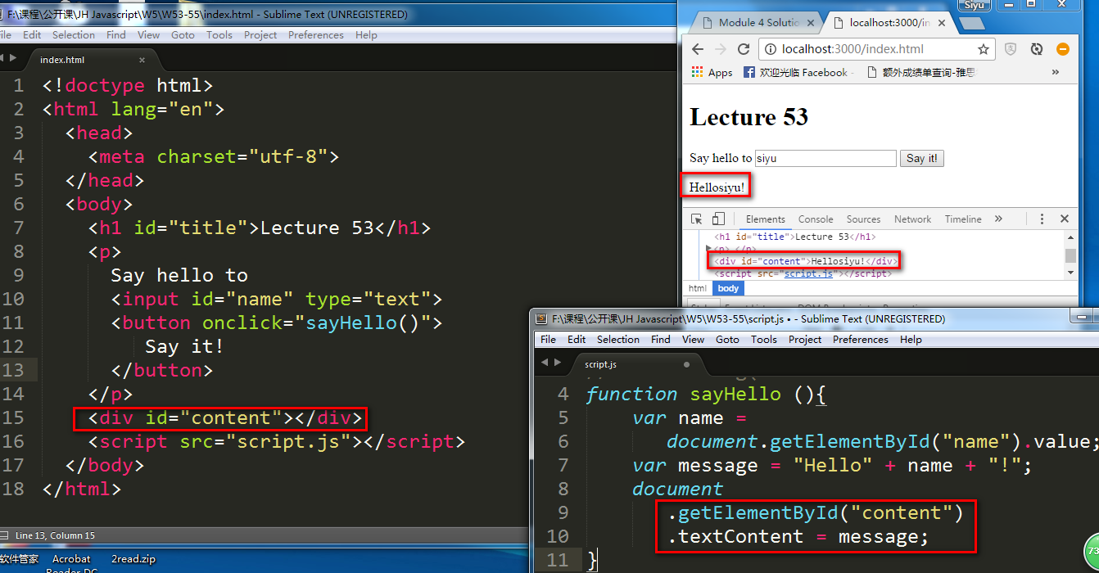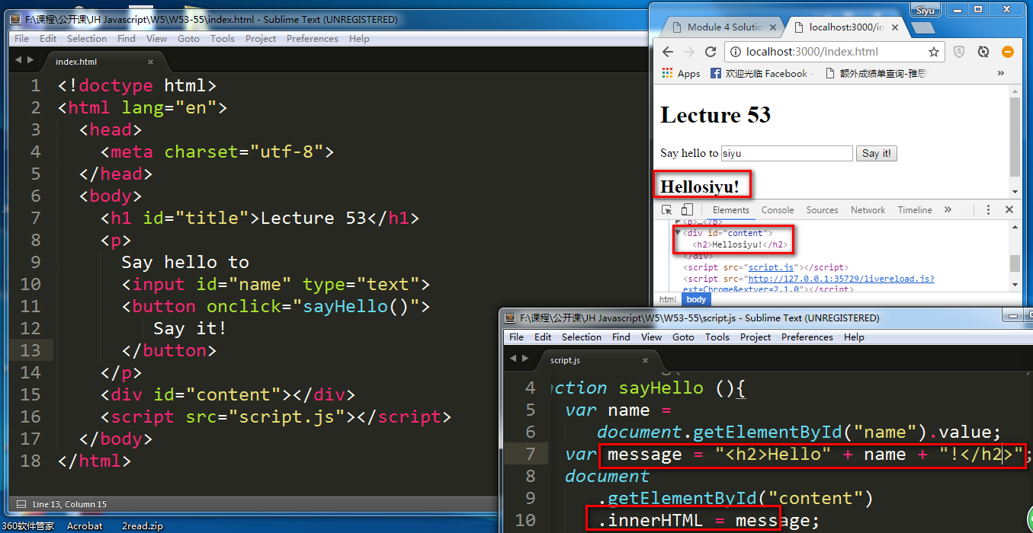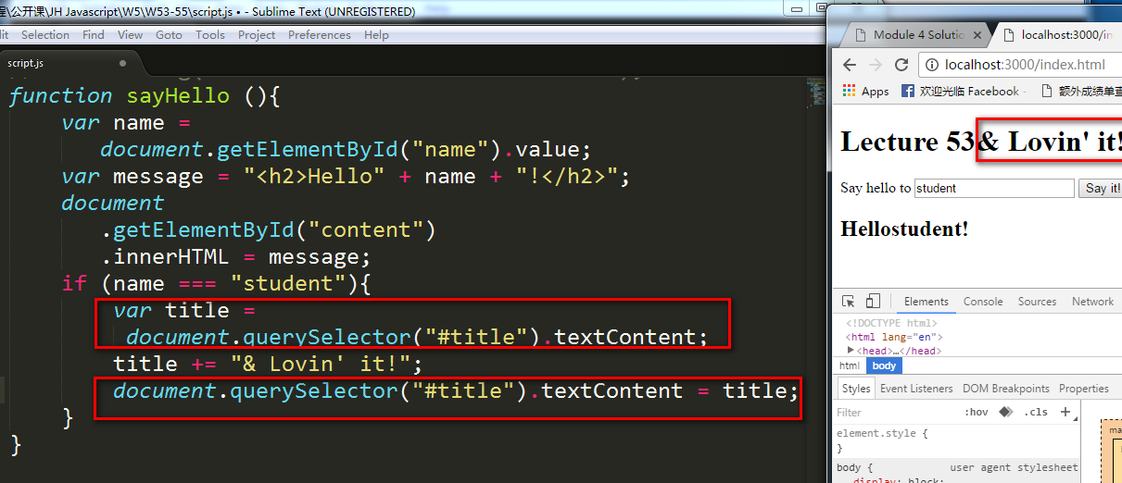

### Handling Events

Html ---onclick=””

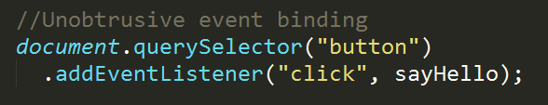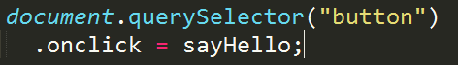

Life cycle event o f the page,actually assign the events to the elements of the page once they load,but before anything else loads,before any images load,before any CSS loads and so forth

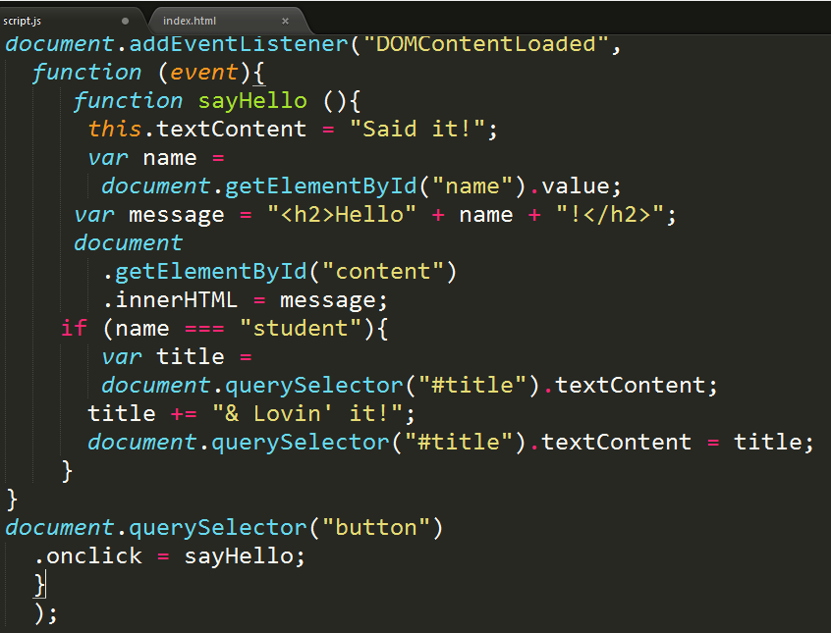

### The event argument

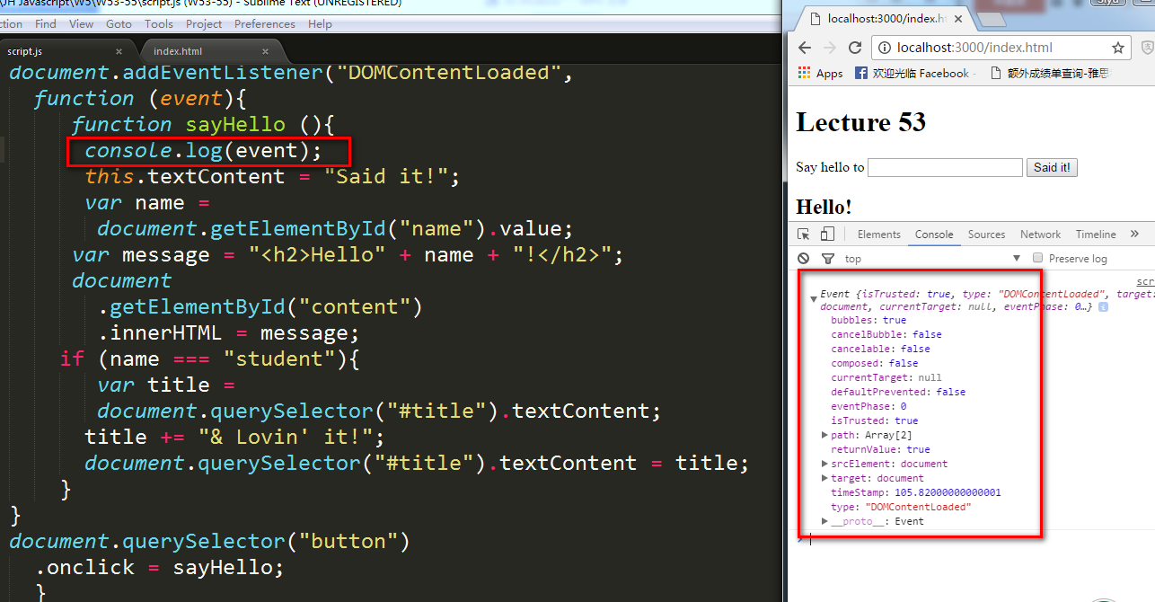

## L56-58

### HTTP Basics

a query string is nothing more than a name value pair separated by ampersand

GET method sends data to server as part of the URL

POST method sends data as part of message body

### Ajax

Asynchronous execution means execution of more than one instruction at a time

Asynchronous instruction returns right away, it sends off its instruction and it’s ready to execution the next one right away,the actual execution is done in a separate thread or process

Synchronous execution means execution of one instruction at a time,can’t start execution of another instruction until the fist instruction finished its execution

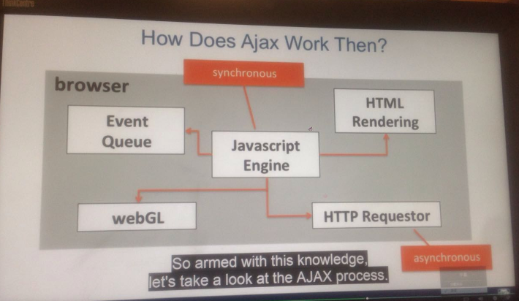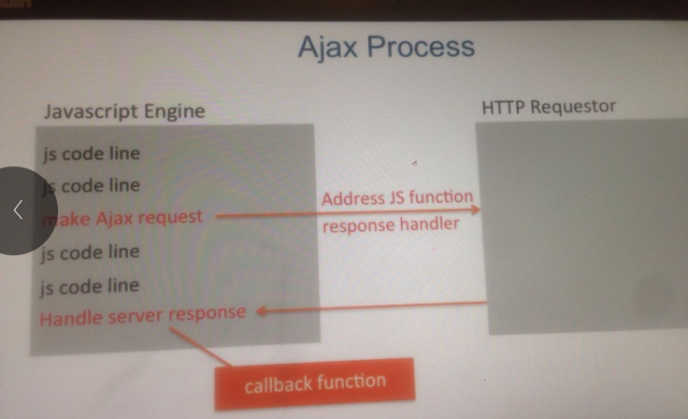

script.js uses things inside of ajax-utils.js

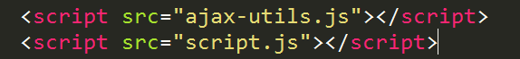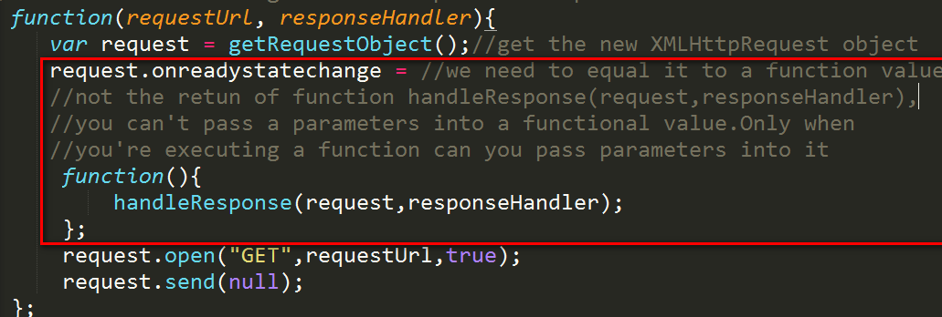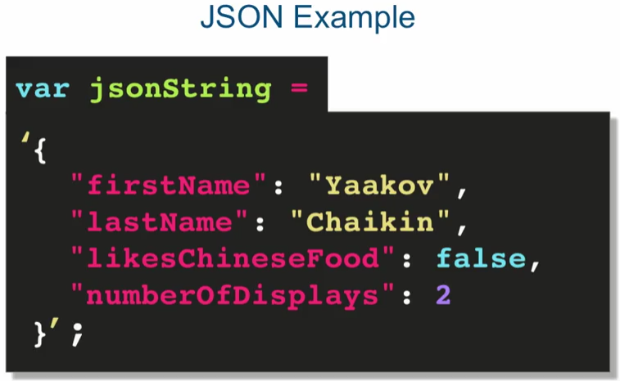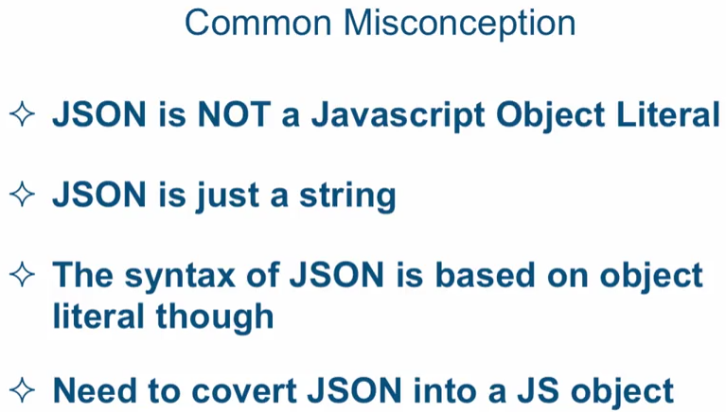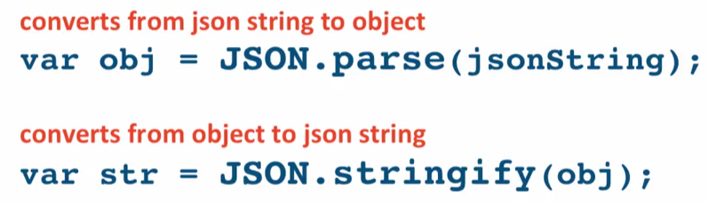

W1 L

ls in Mac, dir in Windows

commit file to git

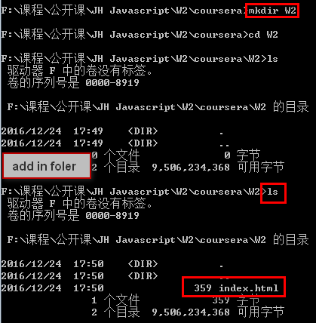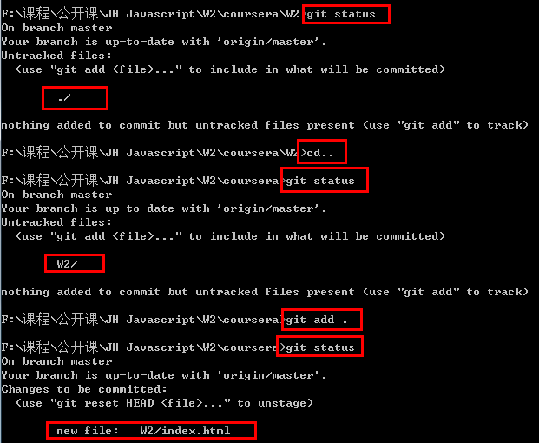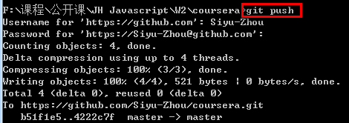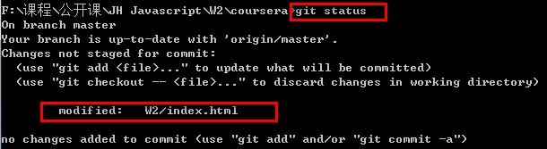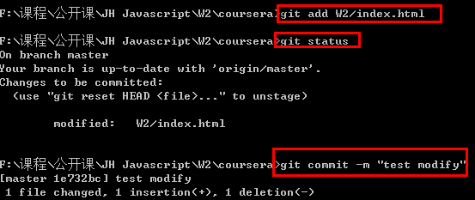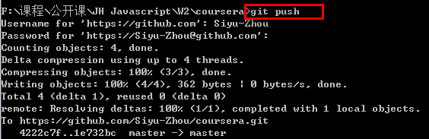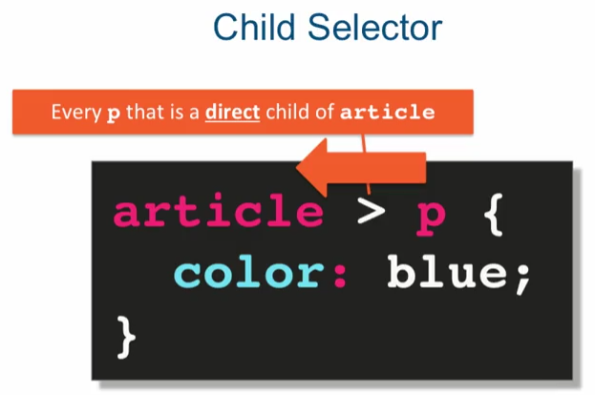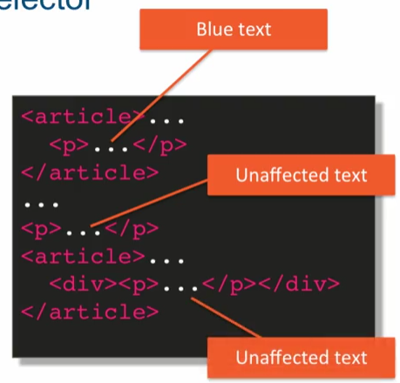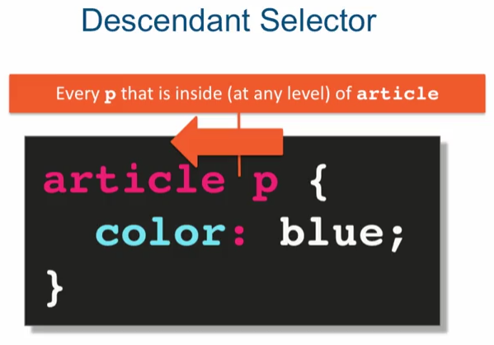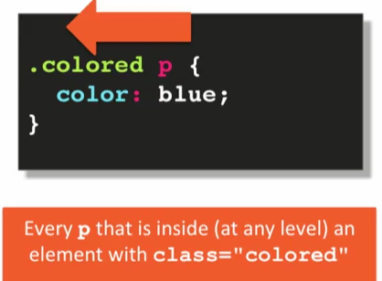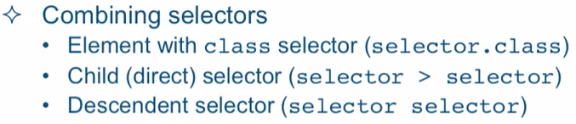

.class1 .class2

Class=”class1 class2”

Link is inner element

Add display: block into block element

a : hover, a : active{}

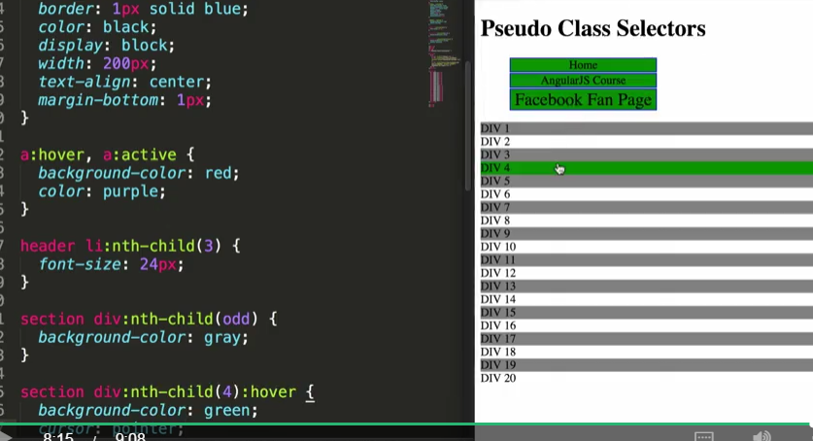

Conflict

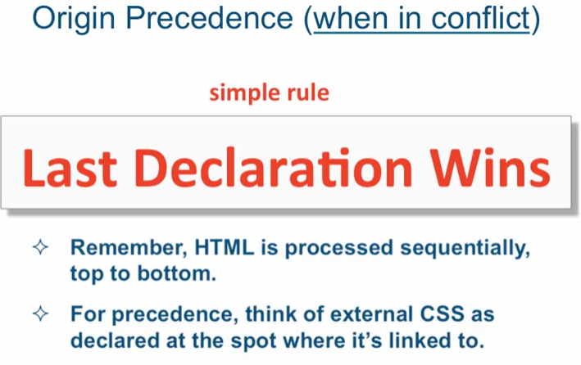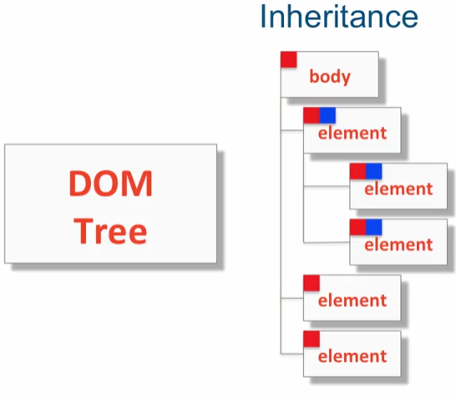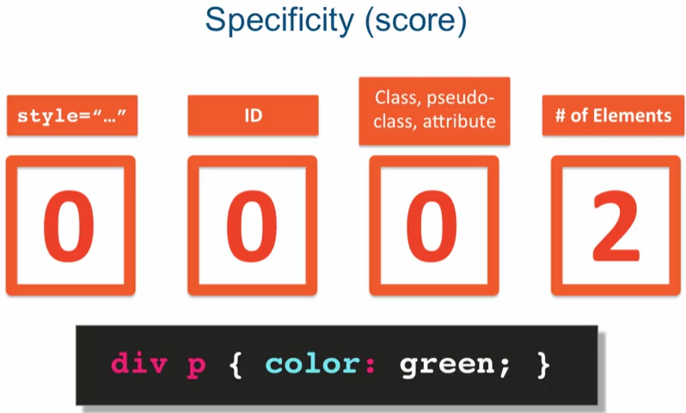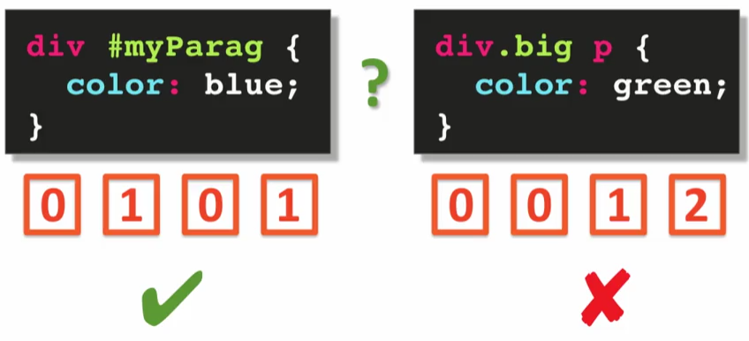

P{

color : green !important

}

Important override everything

P{

Font-family: “Times New Roman”, Times,serif

}

And the reason you put not just one font, but a few fonts is because when you specify font-family in this way, you're relying on the client's computer, you're relying on the user's computer to have that font installed. And it's possible that a particular font will not be installed on the user's computer, so you want to provide some options

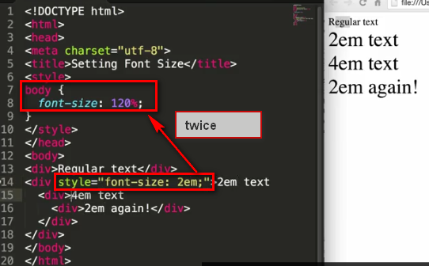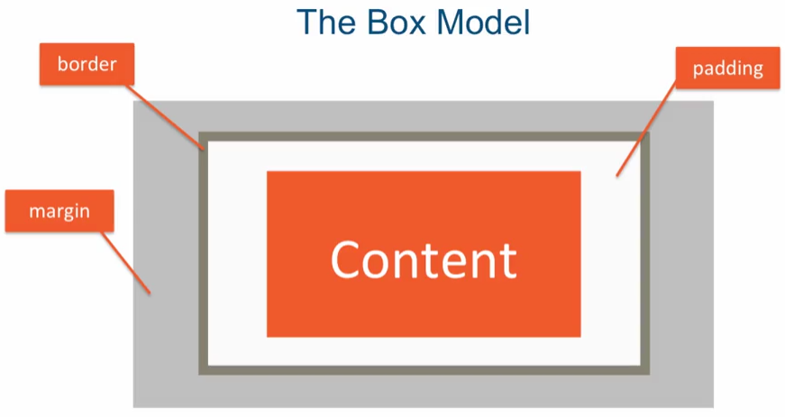

Width: 300px; //for content

box-sizing: border-box //change 300 to all without margin

box sizing is one of those CSS properties that is not inherited

body{

box-sizing: border-box

}// doesn’t work in box

*{}// work

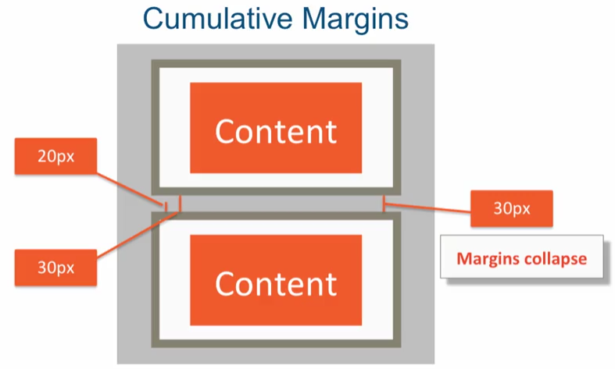

Horizen margin is cumulate

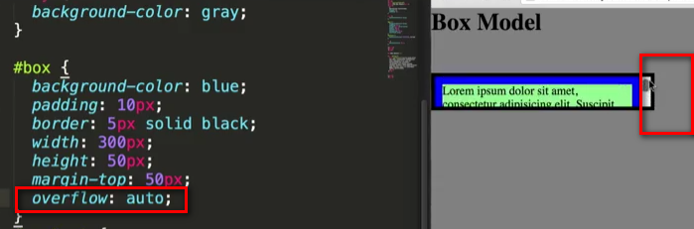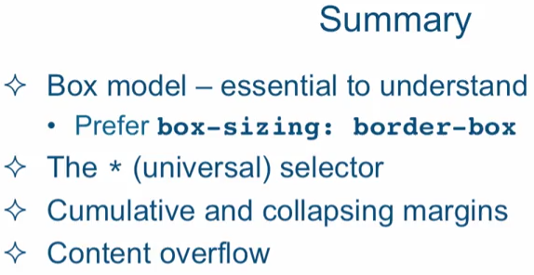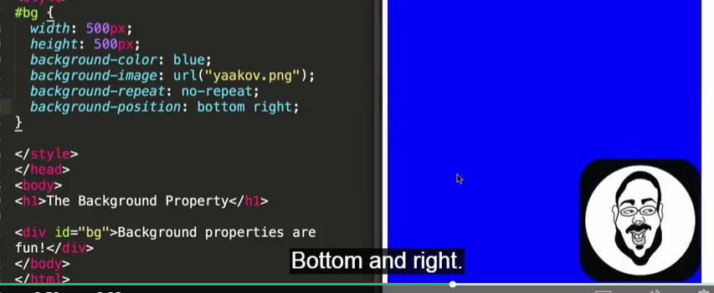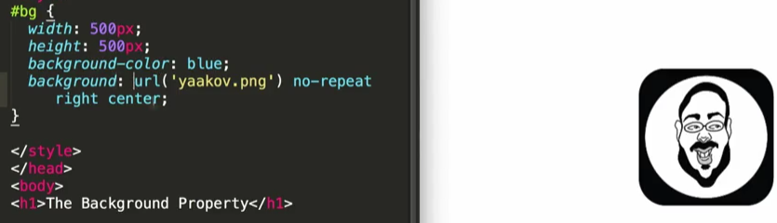

 the reason it disappeared is because my background property is being specified after the background-color property. And since choose to used the background without the dash for a particular property, it's overriding every single property except the ones that I'm actually specifying.



 However, when it comes to floated elements, the margins never collapse.

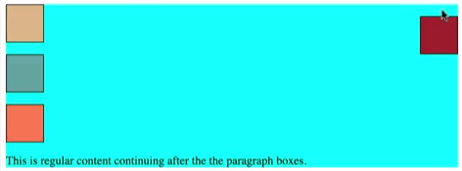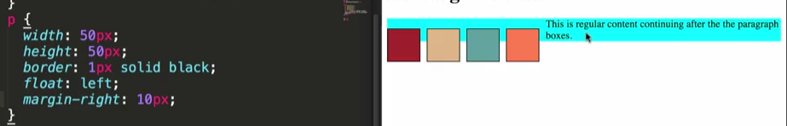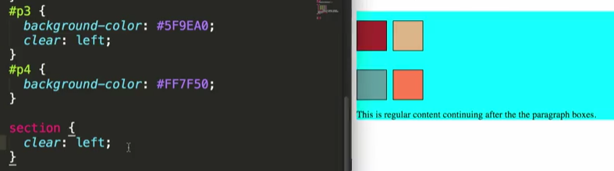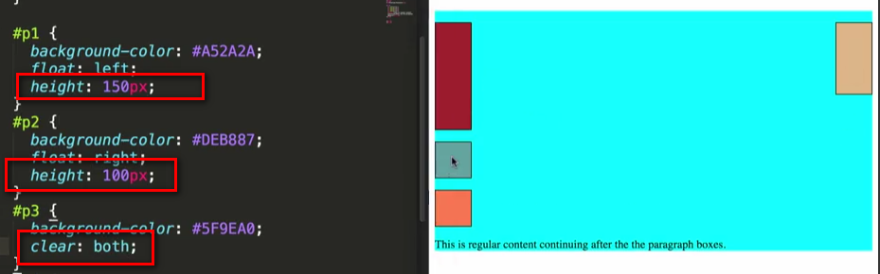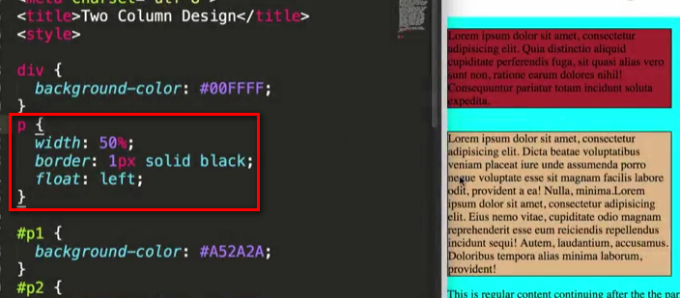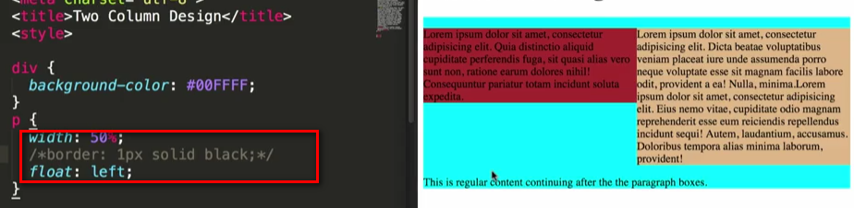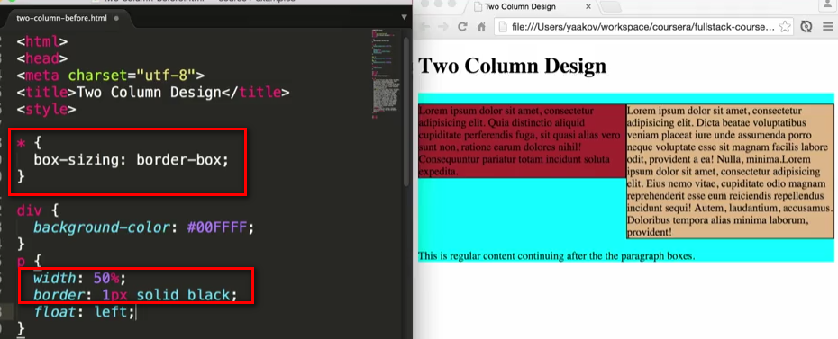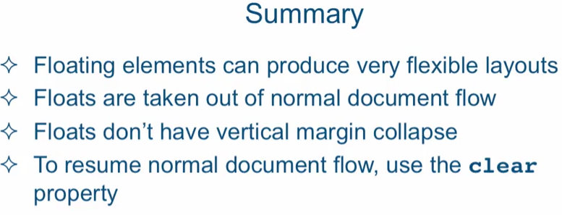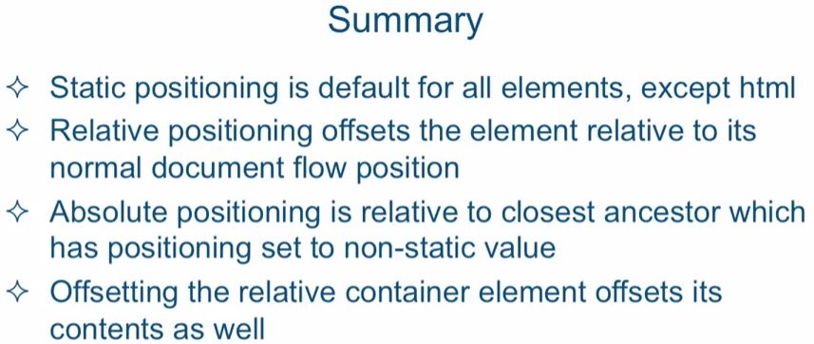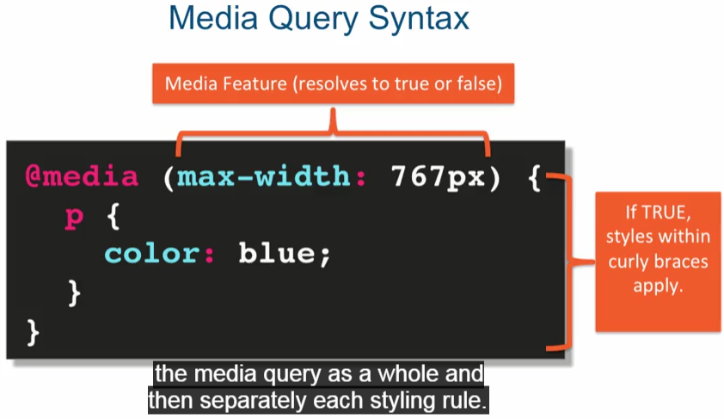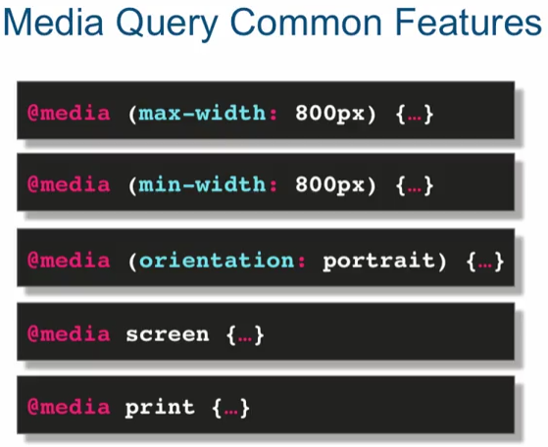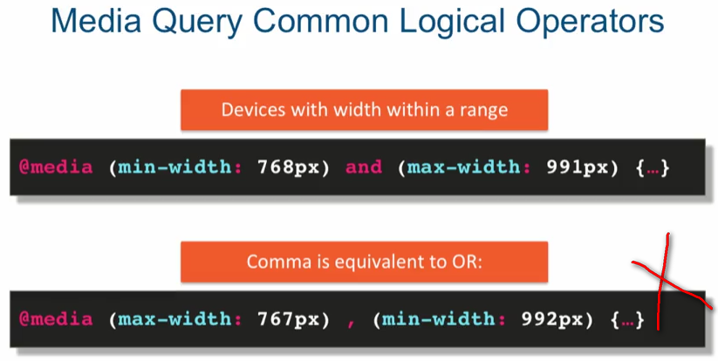

Careful not to overlap range boundaries

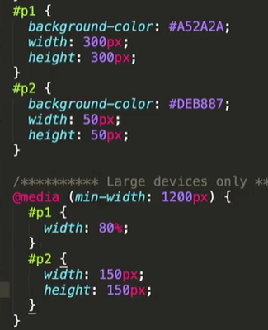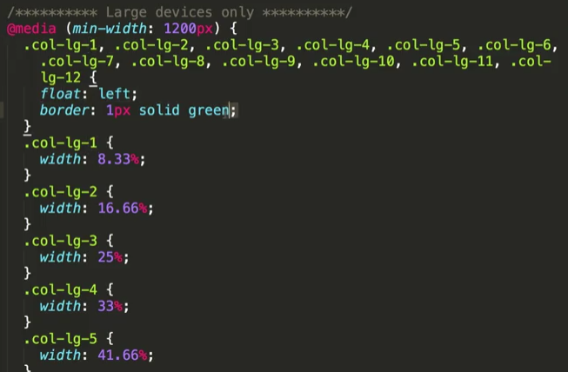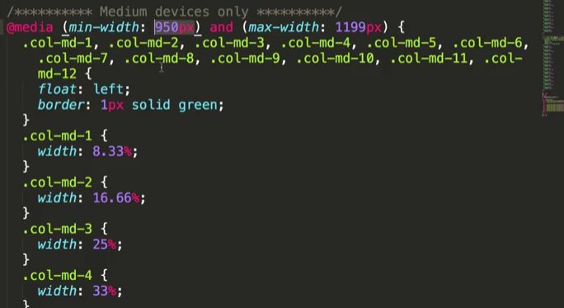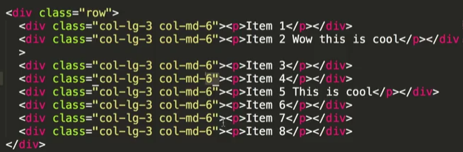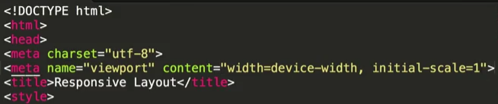

Turn off zooms

